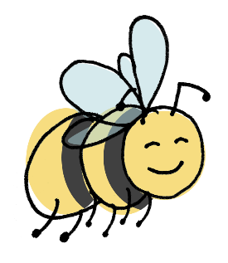
Bumble
Bee
Physio

BBP SDR Superheroes Project Consent Form

Consent
Child’s name:
Parent’s name:
I give consent for the below information about my child to be shared on social media, and on the Bumble Bee Physio Ltd website (please tick)
I give consent for the photos I have provided of my child to be shared on social media, and on the Bumble Bee Physio Ltd website (please tick)
I understand that all information and photos will be stored in accordance with GDPR and healthcare professional guidance from HCPC, CSP and ICO (please tick)
Signature:
Name (printed):
Date:

SDR Superhero Information
First name:
Favourite thing:
Type of CP:
1 or 2 disabilities pre SDR:
1 or 2 abilities post SDR:
Any additional information you or your superhero would like included:

